COMMAND AND STAFF GENERAL

PREPARE A ROAD MOVEMENT TABLE
071-332-5031

CONDITIONS

During combat operations, CPS, FTX, or peacetime contingency, given commander’s/S3’s guidance (to include time available for preparation), general data, unit SOP, and subordinate unit’s serial or march units.

STANDARDS

Within the time specified by the commander/S3, the road movement table annex must—

1. Be correctly identified by title and map reference data.

2. Contain correct classification markings and downgrading instructions, if applicable.

3. Contain correct distribution instructions and proper authentication if distributed separately.

4. As a minimum, show serial or march units, speed, traffic density, proposed locations, routes, and arrival and clearance times at critical points.

TRAINING AND EVALUATION
Training Information Outline

1. Road Movement Table. The road movement table is a means of providing movement schedules and other essential details pertaining to road movement to subordinate units. The road movement table provides—
a. Proposed locations of elements at various times for the column commander.
b. Arrival and clearance times at critical points along the route for serial and march unit commanders.

2. Distribution. Road movement tables frequently require a wider distribution than a normal operation order so that copies can be issued to movement control personnel, traffic posts, and so on.

3. Security Classification. The security classification is based on the content of the road movement table and is not necessarily the same as that of the operation order.

4. Preparation. Road movement tables consist of two parts (Figure 1).
a. The first part includes data paragraphs containing general information common to two or more columns (or elements of a column).
(1) Average speed.
(2) Traffic density (the average number of vehicles that occupy 1 mile or 1 kilometer of road space).
(3) Halts.
(4) Route (for example, between start points and release points).

Note: The routes and points are described by grid references, code words, and so on. If necessary, they are numbered or lettered for ease of reference in the road movement table.

(5) Critical points:
(a) Start points.
(b) Release points.
(c) Other critical points.
(6) Route classification (if applicable).
(7) Route restrictions (if applicable).
(8) Main routes to start points (if applicable).
(9) Main routes from release points (if applicable).

Note: A critical point is a selected point along a route used for reference in giving instructions. This includes start points, release points, and other points along a route, such as bridges or intersections, where interference with movement may occur or where timing is critical.

b. The second part of the movement table (Figure 1, page 3-176) is a listing of the columns (or elements of a column), together with all other necessary information, arranged in tabular form. The following information applies to the tabular form:
(1) Because the form may be issued to personnel concerned with traffic control, security is important. Including dates or locations may not be desirable.
(2) If the tabular form is issued alone and not as an annex to a more detailed order, the form must have a heading and be signed or authenticated the same as for an annex issued separately.

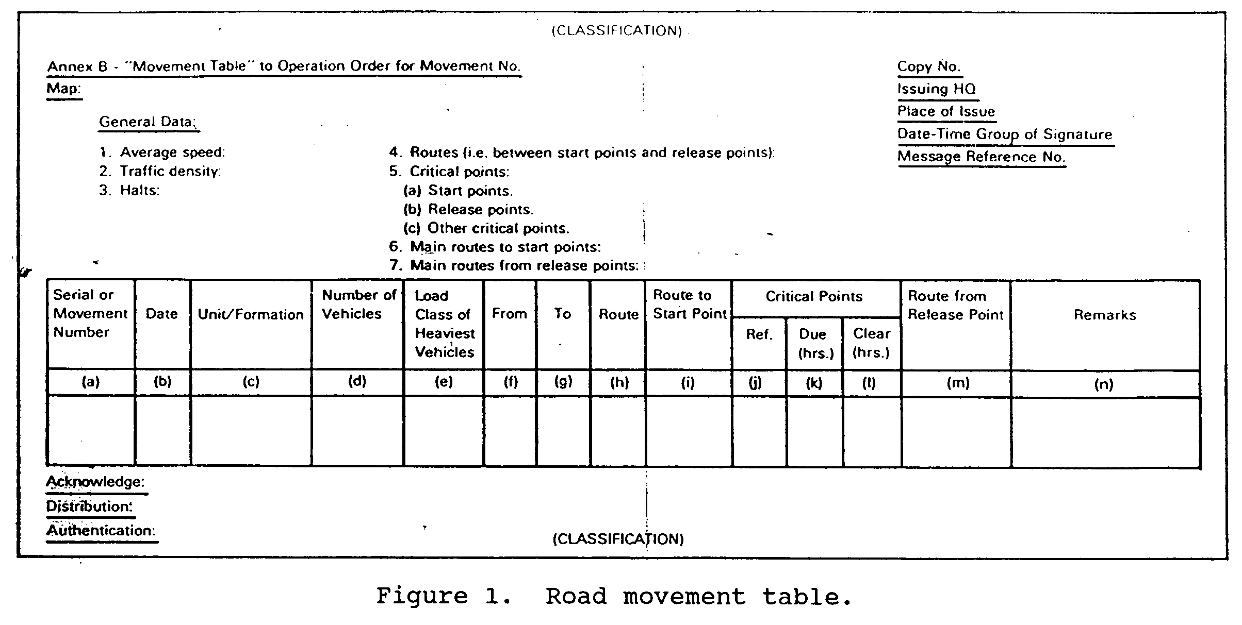

Figure 1. Road movement table.

(3) For simplicity, only the minimum number of column headings should be used. Information that is common to two or more march units should be included in the general data paragraph.

Note: If the annex has the same distribution as the operation order, including the headings and endings as shown in Figure 1 is not necessary.

5. Example Annex. Figure 2 is an example of a completed annex (road movement table) to a battalion OPORD. Note the following points.
a. In paragraph 4 of the general data section, points are designated by names and grid references. Routes are labeled with code words.
b. In blocks (f) and (g) of the tabular form section, point names are given, but not grid references. In block (h), the code word for the route, which is given in the general data section, is used.

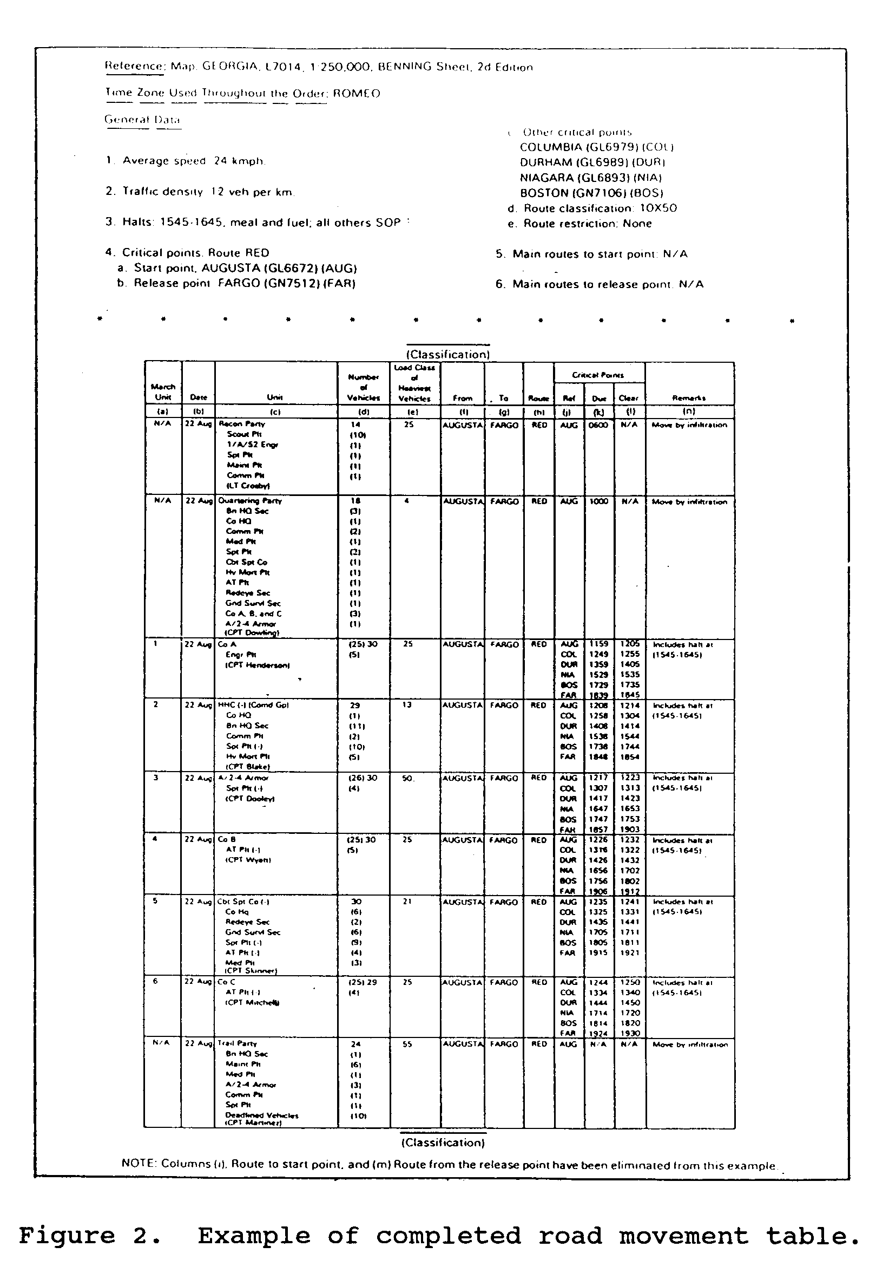

Figure 2. Example of completed road movement table.

EVALUATION PREPARATION

Setup: Provide the soldier with all materials listed in the conditions statement.

Brief Soldier: Tell the soldier to prepare a road movement table and provide proper information. The soldier must provide a movement schedule and other essential details pertaining to the road movement.

EVALUATION GUIDE

Performance Measures Results

1. Provide a schedule for the road movement table. P F

2. Determine distribution of information. P F

3. Assign a security classification based on the content
of the movement table. P F

4. Prepare the road movement table. P F

FEEDBACK

Score the soldier GO if all steps are passed. Score the soldier NO-GO if any steps are failed. If the soldier fails any steps, show what was done wrong and how to do it correctly.

REFERENCES

Required Related
None FM 7-20
FM 55-30

